Q. Demonstrate Telnet in Packet Tracer.

Aim: To configure Telnet on routers to enable remote administration and test remote connectivity between devices.

Devices Needed:
2 Routers
- Switch
- PCs (Telnet Clients) Connection Guide:
Connect Router0 and Router1 via serial cable (Serial DCE)
Connect Router0 to Switch via FastEthernet
Connect PCs to Switch via copper straight-through cables Topology:
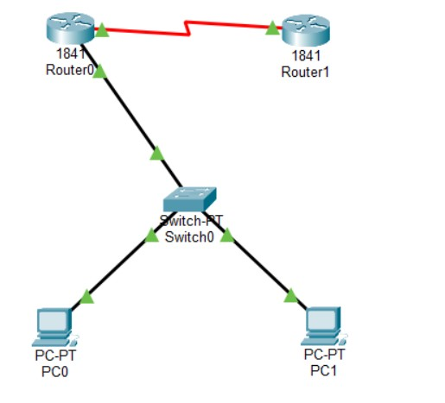

Code:
Router1 Configuration:

Router>enable
Router#configure terminal

Router(config)#hostname Router0
Router0(config)#interface FastEthernet0/0
Router0(config-if)#ip address 192.168.1.1 255.255.255.0
Router0(config-if)#no shutdown
Router0(config-if)#exit
Router0(config)#interface Serial0/0/0
Router0(config-if)#ip address 10.0.0.1 255.255.255.252
Router0(config-if)#clock rate 64000
Router0(config-if)#no shutdown
Router0(config-if)#exit
Router0(config)#line vty 0 4
Router0(config-line)#password cisco
Router0(config-line)#login
Router0(config-line)#exit
Router0(config)#enable secret class
Router0(config)#ip route 0.0.0.0 0.0.0.0 10.0.0.2
Router0(config)#exit
Router0#copy running-config startup-config

Router2 Configuration:

Router>enable
Router#configure terminal
Router(config)#hostname Router1
Router1(config)#interface Serial0/0/0
Router1(config-if)#ip address 10.0.0.2 255.255.255.252
Router1(config-if)#no shutdown
Router1(config-if)#exit
Router1(config)#interface FastEthernet0/0
Router1(config-if)#ip address 172.16.1.1 255.255.255.0
Router1(config-if)#no shutdown
Router1(config-if)#exit
Router1(config)#line vty 0 4
Router1(config-line)#password cisco
Router1(config-line)#login
Router1(config-line)#exit
Router1(config)#enable secret class
Router1(config)#ip route 192.168.1.0 255.255.255.0 10.0.0.1
Router1(config)#exit
Router1#copy running-config startup-config PC1 Configuration:
IP Address: 192.168.1.10
Subnet Mask: 255.255.255.0

Default Gateway: 192.168.1.1

Configuration:
IP Address: 192.168.1.11
Subnet Mask: 255.255.255.0
Default Gateway: 192.168.1.1

Verification: In PC Command Prompt PC1 Telnet Tests:
C:\>ping 192.168.1.1
C:\>ping 10.0.0.2
C:\>ping 172.16.1.1
C:\>telnet 192.168.1.1
C:\>telnet 10.0.0.2

PC2 Telnet Tests:
C:\>ping 192.168.1.1
C:\>ping 10.0.0.2

C:\>ping 172.16.1.1

C:\>telnet 192.168.1.1
C:\>telnet 172.16.1.1

Router Verification Commands:
Router#show users
Router#show line vty 0
Router#show running-config | include vty Output:
PC1 Telnet to Router1: telnet 192.168.1.1
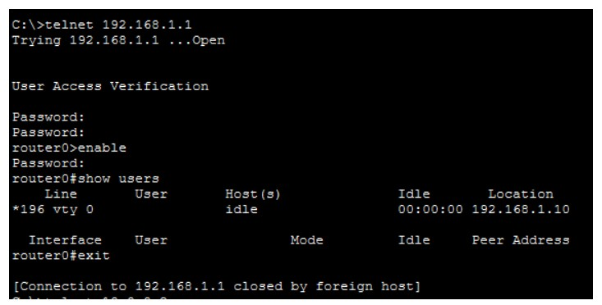

PC1 Telnet to Router2:

C:\>telnet 10.0.0.2
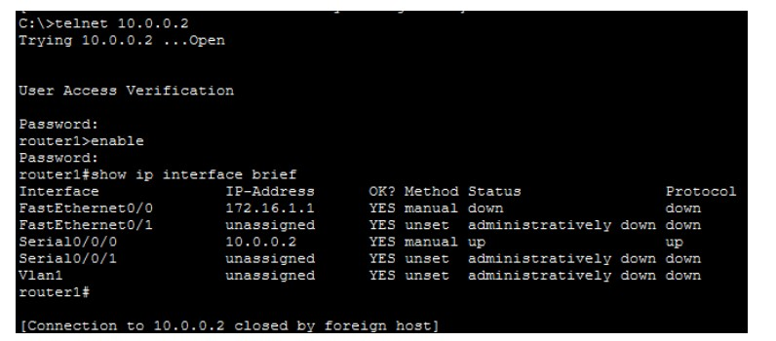

PC2 Telnet to Router1:
C:\>telnet 192.168.1.1
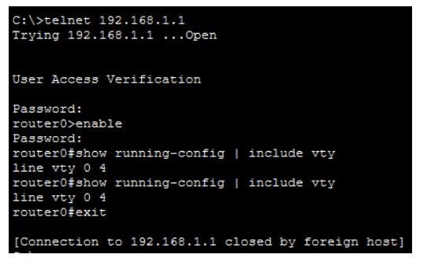

Results:
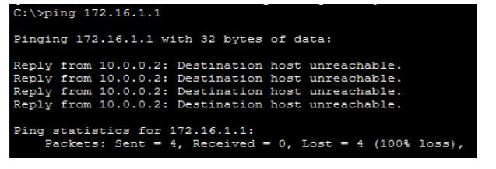

Router Show Users Output:
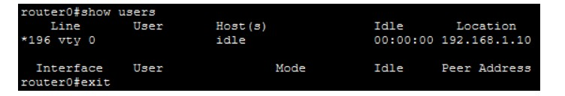

Conclusion: Telnet has been configured successfully on both routers.

